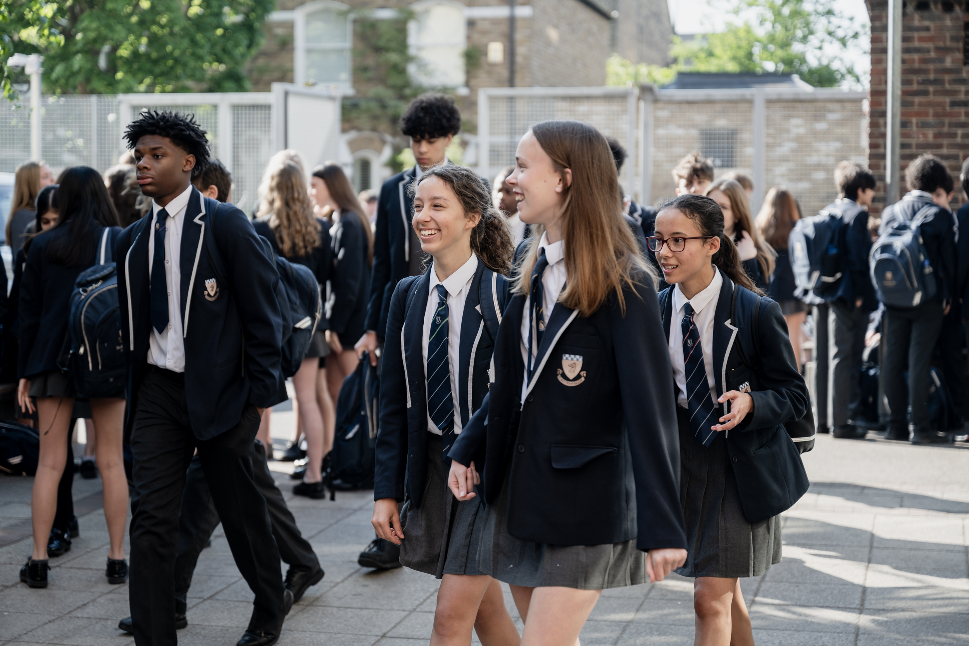

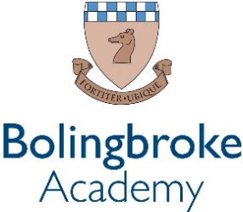

Music Technician
(Fixed-term 1 Year)

An exciting opportunity has arisen for dedicated technician to develop their experience within our passionate and ever courageous community.

We are a courageous, compassionate community - empowering excellence. We are a value lead organisation, being bold within every aspect of our lives at school.

We want all staff to thrive, modelling leadership and determination to the pupils and students within our rich and diverse academy, working together to fulfil our vision of creating a centre of excellence within our local community.

We empower our teams by valuing the individual and prioritising professional development. This is delivered through weekly CPD sessions, dedicated line management meetings and by encouraging staff to develop their own ideas and projects, within their departments and beyond.

Bolingbroke Academy is a uniquely exciting, fulfilling and innovative place to work, learn and grow. We are proud to be rated as ‘Outstanding’ in all five categories in the 2024 Ofsted inspection. Ofsted’s recent parent survey also ranked us as the ‘happiest secondary school’ in Wandsworth.

The Role
The School is currently looking for a part-time Music Technician to join the Music Department.
Our Music Department is a busy environment offering students a broad spectrum of specialisms. Music is an integral part of the curriculum throughout the school and there is a growing take up of the subject across all the years. The appointed Music Technician will be given training if required.
We are looking for a creative individual with strong musical knowledge. Duties will include supporting and enhancing the teaching and learning experience of pupils, assisting the Music Department in raising its profile across the whole school, as well as on national and international levels through various events. The role will also involve managing music equipment and overseeing/doing repairs.

The successful applicant will be enthusiastic and adaptable, able to work in an administrative as well as creative capacity, organising systems and keeping records, as well as offering more practical support in the classroom. The classroom areas for Music are engaged and lively centres of learning, but also provide calm quiet spaces for independent practice. The pupils are motivated and whilst they work well independently on, they may require individual help from the Music Technician.

Reports to: Head of Music
Start date: September 2025
Working Hours: Part Time – 7 hours a week, term-time only, with potential flexibility for events (subject to review at Christmas)
Contract: Fixed-term, 1 year
Salary: Ark Support Payscale, Grade 2, Point 2 (£14.78 per hour)
Closing Date: 7th July 2025

Roles and Responsibilities:

Music Events:

- Preparation and logistics for music concerts (set up on the days, transport hire, liaising with church, letters, permission slips, refreshments, rehearsal schedule, programme printing, posters)
- ABRSM exam entries and overseeing the day itself
- Open Mic Nights

General:

- Upkeep of musical instruments and resources (e.g. repairs, tuning guitars and drums)
- Leading and supporting school enrichments
- Manage rehearsal spaces during breaks and lunchtimes and support bands and ensembles during rehearsals
- Booklet and resources printing
- Set up for classroom lessons and enrichments
- Recording A Level and GCSE performances/compositions
- Supporting in mac/composition and performance Music lessons with Year 7-11
- Maintaining and ordering music stationery

Benefits:
- Use of facilities/instruments/recording studio/rehearsal space outside of office hours
- Access to photocopier

