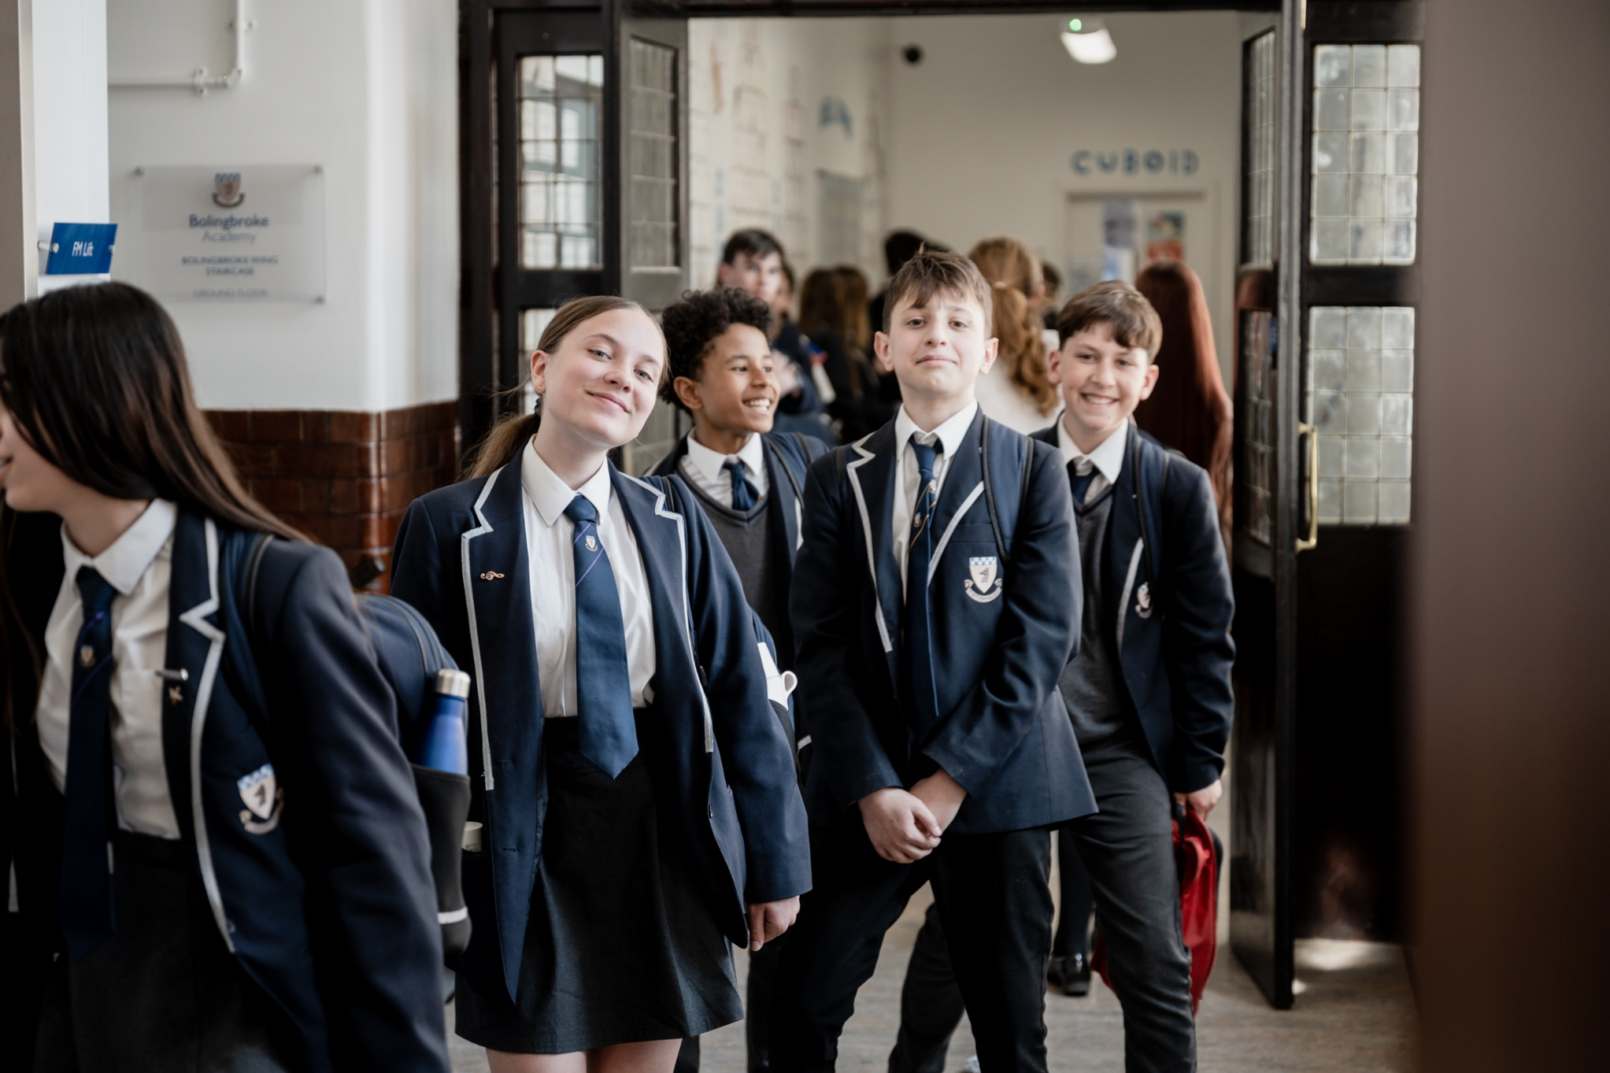

**Communications Assistant**

**An exciting opportunity has arisen for a Communications Assistant to develop their career within our passionate and ever courageous community**

We are a courageous, compassionate community - empowering excellence. We are a value lead organisation, being bold within every aspect of our lives at school.

We want all staff to thrive, modelling leadership and determination to the pupils and students within our rich and diverse academy, working together to fulfil our vision of creating a centre of excellence within our local community.

We empower our teams by valuing the individual and prioritising professional development. This is delivered through weekly CPD sessions, dedicated line management meetings and by encouraging staff to develop their own ideas and projects, within their departments and beyond.

Bolingbroke Academy is a uniquely exciting, fulfilling and innovative place to work, learn and grow. We are proud to be rated as ‘Outstanding’ in all five categories in the 2024 Ofsted inspection. Ofsted’s recent parent survey also ranked us as the ‘happiest secondary school’ in Wandsworth.

**The Role**

The Communications Assistant role is vital to promote and enhance communication between the school and its community, drive engagement, and ensure effective use of communication tools and platforms in a timely manner.

**Reports to:** PA to Principal & Admissions Manager

**Start date**: September 2025

**Contract:**  Permanent, Term-time only plus 2 weeks (8am to 5pm)

**Salary**: Ark Support Payscale Grade 5, Point 8-12 (30,288 - £32,148) - Subject to pro-rata

**Closing Date**: Monday, 11th August 2025

**Key Responsibilities**

**Weekly School Bulletin:**

* + Collate and create the weekly school bulletin for parents to drive engagement.
  + Link stories to the school website and include relevant links in the bulletin.

**Engagement Tracking:**

* + Track the engagement of parents and carers with all academy events.
  + Work closely with the Safeguarding and Pupil Welfare Assistant to monitor and improve engagement.

**Communications Oversight:**

* + Oversee all communications to parents via Bromcom.
  + Ensure the school maximises Bromcom features to achieve excellent satisfaction rates from parents/carers in annual surveys.

**Enrichment Timetable:**

* + Oversee the enrichment timetable and registration.
  + Manage communications to parents/carers and young people regarding enrichment activities.

**Reception Management:**

* + Lead and manage the first impressions of the school via reception.
  + Maintain effective visitor communications and ensure safeguarding protocols are followed.

**School Photos:**

* + Oversee the arrangement of school photos for internal and external communications.
  + Ensure proper storage and management of school photos for communication purposes.

**Other Responsibilities**

* + Complete requisite administrative tasks in an efficient and effective manner.
  + Participate in and contribute to team development initiatives.
  + Be an effective role model for other members of staff.
  + Be committed to personal development and attend training as requested, including any mandatory training identified for this post.
  + Be trained as a Fire Warden for the school.

**Person Specification**

**Qualifications and Skills**

* Right to work in the UK.
* The role is subject to an Enhance DBS clearance
* Experience in communications, preferably within an educational setting.
* Proficiency in using communication tools and platforms, including Bromcom.
* Strong organizational and administrative skills.
* Excellent written and verbal communication skills.
* Ability to work collaboratively with staff, students, and parents.
* Strong attention to detail and ability to manage multiple tasks simultaneously.
* Commitment to safeguarding and promoting the welfare of children and young people.
* Ability to work on own initiative, as well as a member of a team.
* Excellent inter-personal skills with the ability to work as part of a team.
* Compliance with the academy’s Health & Safety policy.

**Personal Characteristics**

* Enthusiastic and proactive approach to work.
* Ability to engage and build positive relationships with parents, carers, and the wider school community.
* Strong problem-solving skills and ability to work under pressure.
* Commitment to continuous professional development.