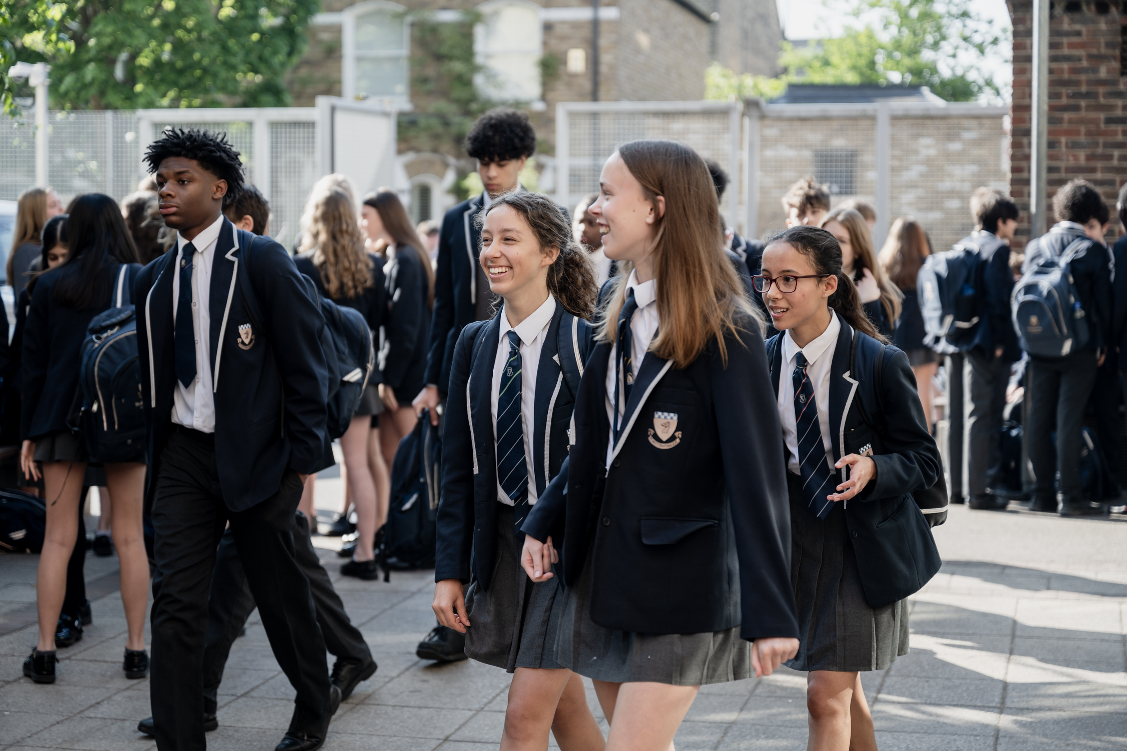

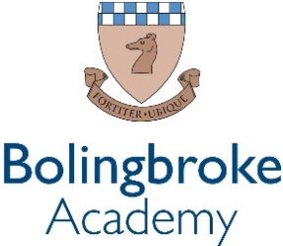

Art Technician
(Fixed-term 1 year)

An exciting opportunity has arisen for dedicated technician to develop their experience within our passionate and ever courageous community.

We are a courageous, compassionate community - empowering excellence. We are a value lead organisation, being bold within every aspect of our lives at school.

We want all staff to thrive, modelling leadership and determination to the pupils and students within our rich and diverse academy, working together to fulfil our vision of creating a centre of excellence within our local community.

We empower our teams by valuing the individual and prioritising professional development. This is delivered through weekly CPD sessions, dedicated line management meetings and by encouraging staff to develop their own ideas and projects, within their departments and beyond.

Bolingbroke Academy is a uniquely exciting, fulfilling and innovative place to work, learn and grow. We are proud to be rated as ‘Outstanding’ in all five categories in the 2024 Ofsted inspection. Ofsted’s recent parent survey also ranked us as the ‘happiest secondary school’ in Wandsworth.

The Role
Our Art Department an extremely successful and well-equipped department offering students a broad spectrum of specialisms including Fine Art, Sculpture, photography, printing and textiles. Art is a very popular subject and is an integral part of the curriculum throughout the school.

With the increasing popularity of the subject at A Level, the Sixth From have an independent studio space. The appointed Art Technician will be given training if required. The position would be suitable for a practising artist or creative person with artistic knowledge. Duties will include helping to support and enhance the Teaching and Learning experience of pupils, supporting the Art Department to continue to drive inclusivity in the arts at a whole school at national and international level supporting with trips while also ensuring that the Art Department remains compliant in all Health and Safety matters.

The successful applicant will be enthusiastic and adaptable, able to work in an administrative as well as creative capacity, organising systems and keeping records, as well as offering more practical support in the classroom. The classroom areas for Art and Design are engaged and lively centres of learning, but also provide calm quiet spaces for independent practice. The pupils are motivated and whilst they work well independently, they may require individual help from the Art Technician.

Reports to: Head of Creative & Performing Arts
Start date: September 2025
Working Hours: Part Time – 9 hours a week, term-time only
Contract: Fixed-term – 1 year
Salary: Ark Support Payscale, Grade 2, Point 2 (£14.78 per hour)
Closing Date: Monday, 11th August 2025

School ethos and culture
- Be committed to Bolingbroke Academy’s ethos of high expectations.
- Deep commitment to Ark’s mission of providing an excellent education to every student, regardless of background
- Excellent interpersonal, planning and organisational skills
- Enrich the curriculum to enhance the learning experience of all pupils.
- Provide a nurturing classroom and academy environment that helps students to develop as learners.
Personal specification
- Degree or professional experience in a relevant subject
- Have a passion to learn and develop your practice through regular CPD and feedback.
- Commitment to equality of opportunity and the safeguarding and welfare of all students
- This post is subject to an enhanced DBS check

