

**Ark Priory Primary**

**Academy**

***Candidate Information Brief***

**Ark Priory Academy**

*Teacher Pack*

**Ark Priory Primary**

**Academy**

***Candidate Information Brief***





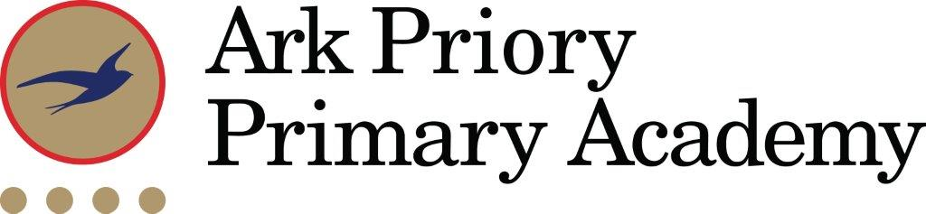

**Class Teacher (EYFS/KS1/KS2)**

**Explore, Endeavour and Excel in an outstanding Ark School in West London**

**Start date:** September 2025

**Salary:** £39,739-£62,500 depending on experience, Ark MPS (Inner London). We welcome applications from experienced teachers who are interested in subject responsibility and ECTs.

**Location**: Acton, London

**Nearest Tube station:** Acton Town

**Nearest Overground station:** Acton Central

**Deadline: noon** on **16th May 2025**

**Interview date: From 19th May 2025**

**Ofsted**: Outstanding – all areas

***Visits to our school are warmly encouraged; to arrange, please call the office on 020 3110 0717***

Ark Priory admitted its first two reception and nursery classes (90 pupils) in September 2013 and in 2019/2020, we had our first cohort of Year 6 pupils. It is a mixed, non-denominational, two form entry primary school for local children in Acton. It offers an inclusive and inspiring education in a community school with the highest possible aspirations for its pupils. We place great emphasis on supporting our pupils to reach their full potential and beyond, to develop and grow to become well-rounded and conscientious citizens of the world that offer a positive contribution to society. Ark Priory had a highly successful first year and was graded outstanding by Ofsted (June 2015).

Our mission, to ensure that all children can attend university or pursue a career of their choice, is incredibly important and something that we keep at the forefront of our minds every day, through our academy values of ‘Explore, Endeavour and Excel’ – today we lay the foundations for tomorrow’s success. By the end of their time at Ark Priory, we expect all children to possess the characteristics highlighted in our ‘*Ark Priory child’*.

Pupils are proud to be Ark Priory pupils and reflect the positive and respectful school culture in which all staff know and care about our pupils. We celebrate togetherness and what makes us part of our unique Ark Priory community, as well as valuing and nurturing differences; in our school bullying, harassment and violence are never tolerated.

Joining Ark Priory Primary Academy is an exciting opportunity to work in an outstanding setting which offers lots of potential and opportunity to embark on a rewarding career path.

**We welcome applications from excellent teachers across all key stages, including those with Early Years Foundation Stage (EYFS) experience.**

**Our ideal candidate will:**

* be an excellent teacher who believes that all pupils can succeed with the right support and care,
* be adventurous and creative,
* be a positive role model for the pupils in their care,
* be able to inspire learning beyond the classroom, ensuring that learning doesn’t stop once the school day ends,
* possess the skills and determination to make a significant difference to the lives of the children,
* be innovative and bring new ideas to the classrooms, and the school
* be ambitious and want to develop in a supportive environment,
* be happy to contribute to the success of this exciting learning community.

Applications must be made by **noon** on **11th October 2024**. **We will review applications as we receive them and may contact applicants before the closing date.**

*Ark is committed to safeguarding children; successful candidates will be subject to an enhanced Disclosure and Barring Service check.*

**Job Description: Class Teacher**

**Reporting to:** Principal

**Start date:** September 2025

**Salary:** Ark MPS (Inner London), £39,739-£62,500, depending on experience

**The Role**

To deliver outstanding teaching and learning and therefore help students achieve excellent academic results and be a role-model/impact the academy more widely.

To design an engaging and challenging curriculum that inspires children to appreciate the range of subjects and their application.

**Key Responsibilities**

* To plan, resource and deliver lessons and sequences of lessons to the highest standard that ensure real learning takes place and students make superior progress
* To provide a nurturing classroom and academy environment that helps students to develop as learners
* To help to maintain/establish discipline across the whole academy
* To contribute to the effective working of the academy.
* Potential to lead a subject

**Outcomes and Activities**

**Teaching and Learning**

* Have a strong understanding of the KS2 framework
* Teach engaging and effective lessons that motivate, inspire and improve pupil attainment
* Use regular assessments to set targets for students, monitor student progress and respond accordingly to the results of such monitoring
* To produce/contribute to oral and written assessments, reports and references relating to individual and groups of pupils
* Develop plans and processes for the classroom with measurable results and evaluate those results to make improvements in student achievement
* Ensure that all students achieve at least at chronological age level or, if well below level, make significant and continuing progress towards achieving at chronological age level
* Maintain regular and productive communication with pupils, parents and carers, to report on progress, sanctions and rewards and all other communications
* Provide or contribute to oral and written assessments, reports and references relating to individual pupils and groups of pupils
* Direct and supervise support staff assigned to lessons and when required participate in related recruitment and selection activities
* Implement and adhere to the academy behaviour management policy, ensuring the health and well-being of pupils is maintained at all times
* Participate in preparing pupils for external examinations.

**Academy Culture**

* Support the academy values and ethos by contributing to the development and implementation of policies practices and procedures
* Help create a strong academy community, characterised by consistent, orderly behaviour and caring, respectful relationships
* Help develop a culture and ethos that is utterly committed to achievement
* To be active in issues of student welfare and support
* Support and work in collaboration with colleagues and other professional in and beyond the school, covering lessons and providing other support as required.

**Other**

* Undertake, and when required, deliver or be part of the appraisal system and relevant training and professional development
* Undertake other various responsibilities as directed by the Principal