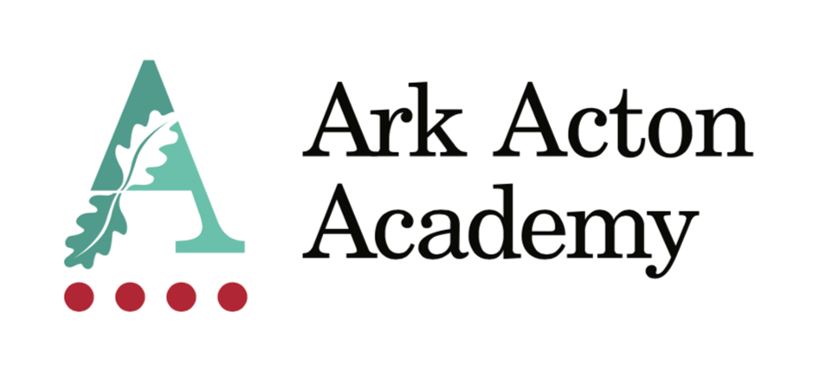

**Learning Support Assistant**

**Recruitment Pack**

**November 2**

Dear Applicant,

Are you passionate about your career? Do you want the development and support to be excel in your role? Are you driven to work with disadvantaged communities?

Ark Acton is a good school, and we are on a mission to make it a great school. From a strong sapling to a mighty oak. Be part of our growth.

We are heavily committed to staff welfare and development, and this includes:

* free use of our leisure centre
* access to the school counsellor

We have high expectations for our pupils – and our staff – but we know that by working as a team and committing to our mission we can shape the future.

We look forward to seeing you at interview

Sarah Donachy

Principal



**Learning support assistant (non-Teaching)**

**November 2024**

**Ark Acton Academy**

**Job Description: Learning Support Assistant**

### Job Title: **Learning Support Assistant**

### Start date: **As Soon As Possible**

### Salary: **Support scale grade 5, points 5-13, £28,977 - £32,634 (Pro-rata ££24,925 - £28,070)**

### Disclosure level: **Enhanced**

### Closing date: **Applications will be considered on a rolling basis**

### Interview date: **TBC**

**The Role**

As a Learning Support Teaching Assistant you will support pupils, parents, and teachers, to establish a supportive learning environment in which children make good academic progress. You will be instrumental in our mission to provide every student, regardless of their background, a great education and real choices in life

**Key Responsibilities**

* Support pupil learning through the delivery of specific learning programmes, setting high expectations whilst encouraging their independence and building their confidence
* Promote inclusion, encouraging pupils to interact and work collaboratively
* Work with the SENCO and other teachers to assess the needs of individual children, contribute to and implement Individual Education Plans
* Adapt and develop resources for EAL and SEND pupils, ensuring their safety and enabling them to access the curriculum
* Assist with follow-through for related services (speech/language/physical therapy etc.)
* Mentor students on a 1:1 and group basis, as well as planning and leading a series of booster and intervention sessions to tackle difficult topics
* Observe, record and feedback information of pupil performance
* Assist in creating materials for curriculum delivery and display boards
* Assist with whole class teaching
* Provide class cover for the teacher
* Use strategies, in liaison with the teacher to assist in behaviour management and to support pupils in their learning objectives
* Assist pupils' achievement outside of the classroom, e.g. computer lab, library

**Other**

* Undertake other various responsibilities as directed by the Principal
* Supervise pupils in playgrounds, lunchrooms etc and assist with general pastoral care
* Accompany teachers and pupils on trips and out of school activities as required within contract hours, taking responsibility for pupils under the supervision of
* the teacher
* Other
* Actively promote the safety and welfare of our children and young people
* Ensure compliance with Arks data protection rules and procedures
* Liaise with colleagues and external contacts at all levels of seniority with confidence, tact and diplomacy
* Work with Ark Central and other academies in the Ark network, to establish good practice throughout the network, offering support where required

This job description sets out the main duties of the post at the time of drafting. It cannot be read as an exhaustive list. These responsibilities will be discussed annually as part of the postholder’s annual performance review and are subject to change. However, it may be altered at any time subject to need in consultation with the postholder subject to the Principal’s approval.

**Person Specification: Learning Support Assistant**

**Qualifications**

* Right to work in UK
* Good literacy and numeracy
* Degree level qualification (ideally 2:1 or above) English preferred
* For those interested in training to teach:
* GCSE math’s and English at grade C or above or equivalent (this a national requirement to enter teacher training)

**Knowledge, Skills, and Experience**

* Experience of establishing successful learning relationships with a variety of children at the relevant age
* Experience and/or understanding of the role of a learning support assistant
* Relentless drive to do whatever it takes to ensure all pupils succeed.
* Embody our core values – integrity, courage, community, and mastery – in all aspects of work and conduct.
* The belief that with the right environment all our pupils can excel at university, or in a meaningful alternative.
* The courage and conviction to make a difference.
* The ability to listen and communicate effectively.
* Empathy and the ability to understand the needs, aspirations and motivation of diverse individuals and groups.
* The ability to influence and motivate others.
* Develop and communicate a shared vision.
* Model desired behaviour and values.
* Empower, support and coach others.
* Hold others to account for high standards of performance.
* Understand and resolve conflict.
* Identify, analyse, and resolve problems and issues.
* Develop plans with concrete outcomes and effective solutions.
* Evaluate results and identify necessary actions.
* Make fact-based decisions.

**Personal Characteristics**

* Sustain energy, optimism, and motivation in the face of pressure and setbacks.
* Stay calm in difficult situations and maintain clarity of vision.
* Be adaptable in the face of adversity.
* Awareness of own strengths and limits.
* Commitment to ongoing improvement and learning.
* A passion for own role and that of others.
* Focus on achieving challenging goals and results.
* Resourcefulness and flexibility in delivering outcomes.
* Effective team worker and leader.
* Demonstrates resilience, motivation, and commitment to driving up standards of achievement.
* Acts as a role model to staff and students.
* Vision aligned with Ark Acton’s high aspirations, high expectations of self and others.
* Other
* Commitment to equality of opportunity and the safeguarding and welfare of all students
* Willingness to undertake training.

This post is subject to an enhanced DBS check.

View more information on our Curriculum [here.](https://arkacton.org/curriculum/subjects/timetable)

For Further information on the school please visit the school site at <https://arkacton.org>

View our Safeguarding information and policy **[here](https://arkacton.org/about/culture-wellbeing/safeguarding)**

View more information on the benefits of working for Ark **[here](https://arkonline.org/about-us/what-we-do)**.

For a sneak peak into school life at Ark Acton Academy [click here](https://www.youtube.com/watch?v=SEmpOxQWVBI)

I look forward to receiving your application and welcoming you to our Academy.

For further information, a confidential discussion or any technical queries please contact [hr@arkacton.org](mailto:hr@arkacton.org)

*Ark is committed to safeguarding and promoting the welfare of children and young people in its academies. In order to meet this responsibility, its academies follow a rigorous selection process to discourage and screen out unsuitable applicants.*

*Ark requires all employees to undertake an enhanced DBS check. You are required, before appointment, to disclose any unspent conviction, cautions, reprimands, or warnings under the Rehabilitation of Offenders Act 1974 (Exceptions) Order 1975. Non-disclosure may lead to termination of employment. However, disclosure of a criminal background will not necessarily debar you from employment - this will depend upon the nature of the offence(s) and when they occurred. To read more about Ark’s safer recruitment process, please click this [link](Y:\\HR\\Recruitment JDs\\Process and Templates\\Ark_safe_recruitment Policy.pdf).*

Ark Schools are committed to attracting, developing and retaining a diverse workforce, with a broad range of backgrounds, experiences and perspectives. To read more about Ark’s diversity and inclusion statement, please click this [link.](https://arkonline.org/sites/default/files/127/attachments/Diversity%20and%20Inclusion%20Statement.pdf)