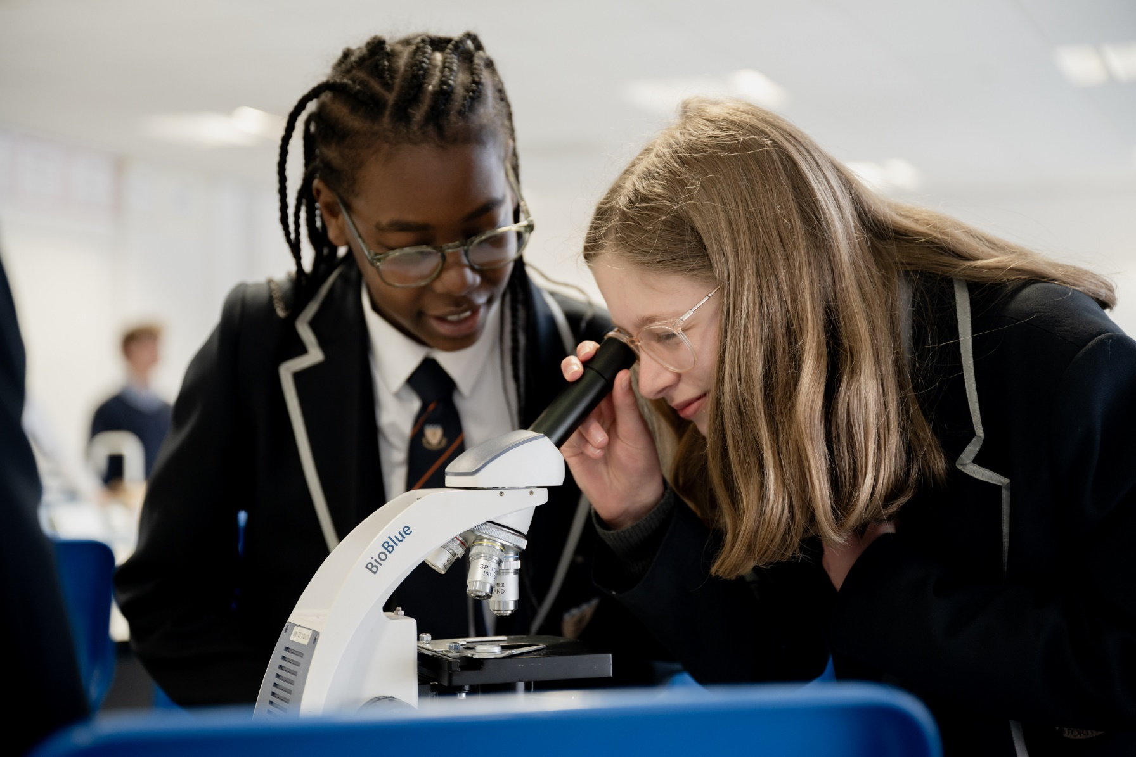



**Science Teacher**

**An exciting opportunity has arisen for a dedicated Science Teacher to develop their career within our passionate and ever courageous community**

We are a courageous, compassionate community - empowering excellence. We are a value lead organisation, being bold within every aspect of our lives at school.

We want all staff to thrive, modelling leadership and determination to the pupils and students within our rich and diverse academy, working together to fulfil our vision of creating a centre of excellence within our local community.

We empower our teams by valuing the individual and prioritising professional development. This is delivered through weekly CPD sessions, dedicated line management meetings and by encouraging staff to develop their own ideas and projects, within their departments and beyond.

Bolingbroke Academy is a uniquely exciting, fulfilling and innovative place to work, learn and grow. We are proud to be rated as ‘Outstanding’ in all five categories in the 2024 Ofsted inspection. Ofsted’s recent parent survey also ranked us as the ‘happiest secondary school’ in Wandsworth.

**The Role**

This is an exciting opportunity for a skilled Science Teacher to develop and steer the Science provision at Bolingbroke Academy. We are seeking to appoint a strong and engaging teacher who is committed to delivering outstanding teaching and learning across all disciplines. We may offer leadership responsibilities and associated allowance to the right candidate based on your experience.

**Reports to:** Head of Science

**Start date**: September 2025

**Contract:** Permanent

**Salary**: £39,739 - £51,545 (Ark Main Pay Scale AM1-AM6)

**Closing Date:** Monday, 12th May 2025

**Key Responsibilities**

**Leadership and Management**

* Have experience of Science teaching at Key Stage 3 and 4 and preferably Physics, Chemistry or Biology at Key Stage 5
* Be an outstanding teacher, able to motivate and challenge learners of all abilities across Key Stages 3-4.

**Strategic Activities**

* Plan, resource and deliver lessons and sequences of lessons to the highest standard that ensure real learning takes place and pupils make superior progress.
* Develop plans and processes for the classroom with measurable results. Interpret and develop results to make improvements in pupil achievement.
* To review and evaluate current exam boards against Ark standards.

**Teaching and learning**

* Exude a passion for the subject which is evident in their day-to-day classroom practice.
* To design an engaging and challenging curriculum that inspires pupils to appreciate the subject and its application and which meets the needs of the pupils.
* To deliver outstanding teaching and learning of Science, thereby helping pupils achieve excellent academic results.
* Have a proven track record of success and raising pupil attainment in Science.
* Ability to understand and interpret pupil data to drive lesson planning and pupil attainment.

**School ethos and culture**

* Be committed to Bolingbroke Academy’s ethos of high expectations.
* Demonstrate high levels of ambition and optimism regarding what the Academy and its pupils can achieve.
* Provide a nurturing classroom and academy environment that helps students to develop as learners.
* Enrich the curriculum with trips and visits to enhance the learning experience of all pupils.

**Other**

* Undertake, and as required, deliver or be part of the appraisal system and relevant professional development.
* Perform additional duties and tasks required for the effective operation of the Academy as directed by your Line Manager and/or Principal.
* Have a passion to learn and develop your practice through regular CPD and feedback.
* The ability to question and challenge the status quo and find new and progressive solutions to existing systems.
* Have strong experience teaching and achieving great results up to Key Stage 4.
* The ability to work in a way that promotes the safety and wellbeing of students and pupils.

**Person Specification**

**Qualification Criteria**

* Appropriate degree.
* QTS qualified.
* Right to work in the UK.

**Experience**

* Experience of raising attainment in a classroom environment.
* Experience of reflecting on and improving teaching practice to increase student achievement.
* Experience of continually improving the teaching and learning of the subject through schemes of work and extra-curricular activities.

**Knowledge**

* Up to date knowledge of the curriculum area.

**Behaviours**

* Motivation to continually improve standards and achieve excellence.
* Effective team worker.
* Genuine passion and a belief in the potential of every pupil.
* Commitment to equality of opportunity and the safeguarding and welfare of all pupils.
* Role model to staff and pupils.
* Vision aligned with ARK’s high aspirations, high expectations of self and others.

**Skills and Attributes**

**Leadership**

* Effective team member and leader.
* High expectations for accountability and consistency.
* Vision aligned with Ark’s high aspirations and high expectations of self and others.
* Genuine passion and a belief in the potential of every pupil.
* Motivation to continually improve standards and achieve excellence.
* Commitment to the safeguarding and welfare of all pupils.

**Teaching and Learning**

* Excellent classroom teacher with the ability to reflect on lessons and continually improve their own practice
* Effective and systematic behaviour management, with clear boundaries, sanctions, praise and rewards
* Ability to understand and interpret complex pupil data to drive lesson planning and pupil attainment.
* Strong communication, planning and organisational skills.
* Demonstrable resilience, motivation and commitment to driving up standards of achievement.
* Ability to act as a role model to staff and pupils.
* Commitment to regular and on-going professional development and training to establish outstanding classroom practice.

**Other**

* Commitment to equality of opportunity and the safeguarding and welfare of all pupils.
* This post is subject to an enhanced DBS check.