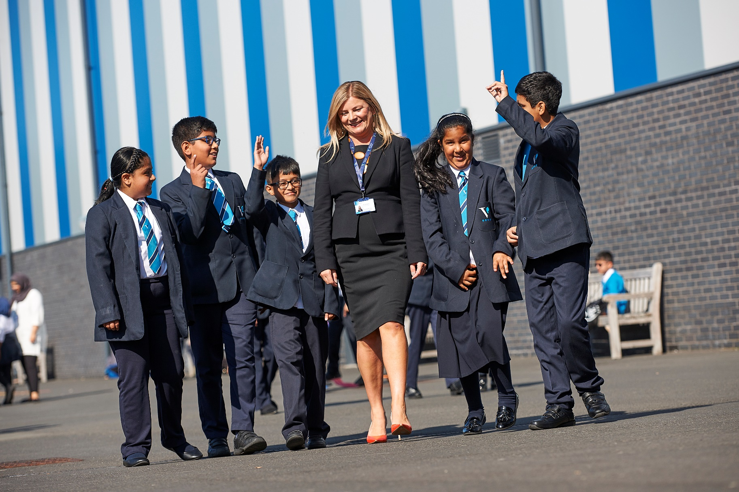

**Premises Assistant**

|  |  |
| --- | --- |
| **Reporting to:** | Premises Manager |
| **Start Date:** | As soon as possible |
| **Location:** | Ark Victoria Academy, Talbot Way, Small Heath, Birmingham, B10 0HJ |
| **Contract:** | Permanent |
| **Working Pattern:** | Full time, all year round (36 hours per week) |
| **Working Hours:** | Your working hours would be agreed between the hours of 8:00am and 6:00pm with potential shift patterns. |
| **Salary:** | Ark Support Grade 5, points 5-12 (£24,790 - £27,711 p/a) |
| **Closing Date:** | **Thursday 26th June 2025 at midday** |

**About the role:**

This is a fantastic opportunity for a new Premises Assistant to join our skilled Premises Team and our wider Operations Department.

As Premises Assistant, you will play an integral role in ensuring the Academy is a safe, inviting and positive learning environment for students, staff and visitors. You will work to ensure the highest quality of site maintenance.

You will support the management and operations of premises-related functions at the academy including buildings and grounds maintenance, security, cleaning, health and safety, lettings of our facilities and contractors.

**About Ark Victoria Academy**

**Ark Victoria Academy provides pupils with an excellent education through an ambitious curriculum, personal development and character programme, and an extensive student experience and extra-curricular offer. Although we are a large school, we are able to retain a family feel, to nurture our pupils through their schooling and ensure that they flourish and leave us with the skills and qualifications necessary to continue their journey of life-long learning in a university or career of their choice.**

Our school values and virtue pathways are crucial to our culture and ethos, they are also part of the way we work and learn together and have been instrumental to us on our school improvement journey. Our values of Ambition, Resilience and Kindness permeate our curriculum, our culture, school and our learning community.

It is for these reasons that Ark Victoria Academy was judged to be significantly improved in all areas from the 2019 ‘Good’ inspection, by Ofsted, in October 2024: *‘This is a school which lives out its values in full for the benefit of children in Nursery to the pupils in Year 11…pupils thrive at all stages of Ark Victoria Academy…as the school knows its pupils very well, they are very well supported to engage with the school’s ambitious curriculum’*. The full report (September 2024) can be found here: <https://files.ofsted.gov.uk/v1/file/50262921>.

We prioritise staff development with a strong emphasis on securing expert subject knowledge from our teachers, strong teaching and leadership and a focus on excellence for our pupils and staff.  **Our** [**website**](https://arkvictoria.org/) **can provide more information about Ark Victoria Academy.**

***Why work for our school?***

We value our staff and provide a comprehensive programme of coaching and professional development for all our staff. We use our values and our virtue pathways to shape the way we work and learn together. Hear what our teachers have to say about working at Ark Victoria Academy: <https://arkvictoria.org/jobs/working-for-us>

* We take CPD seriously, which is why we offer twice the number of training days as standard
* A white rectangle on a black background

  AI-generated content may be incorrect.Our school’s ‘Wellbeing Wednesdays’ are a great hit – get in touch to find out more
* Our staff can take advantage of our on-site fitness suite
* Access to Ark Rewards scheme offering up to £1,000 a year in savings from over 3,000 major retailers
* Interest-free loans of up to £5,000 available for season tickets or a bicycles
* Gym discounts offering up to 40% off your local gym

For an informal conversation about the role please contact HR Manager, Kelly Mubarik, via 0121 393 4459 or via [k.mubarik@arkvictoria.org](mailto:k.mubarik@arkvictoria.org).

*Please note the school reserves the right to close this advert early and interviews may take place before the advertised closing date. Applicants are strongly encouraged to apply early for this role to avoid disappointment.*

**How to Apply:**

Please submit your application online by visiting <https://arkvictoria.org/jobs/vacancies>.

**Job Description**

**Key Responsibilities**

**Health, Safety and Security**

* Work with the Premises Manager to ensure compliance with Health and Safety legislation and guidance
* Act as an academy first aider
* Act as an academy minibus driver
* Work with the Premises Manager to ensure cover for all agreed Academy opening hours, which may include evening and weekend use
* Work with the Premises Manager to ensure the general security of the buildings and grounds
* Assist with maintaining risk assessments and management plans ensuring that they are up to date and comply with any action plans to rectify any deficiencies identified
* Work with the Premises Manager in conducting routine inspections and keeping records using the building management system
* Report and make safe any hazards on site (internal and external, reporting these to Premises Manager
* Follow fire safety and evacuation measures and ensure fire risk assessments are followed

**Buildings and Grounds Maintenance**

* To ensure that all plant and other equipment are available and working effectively during the opening hours of the academy and adjusted as required for evening and weekend use
* Undertake site and maintenance work on the grounds, ensuring the work is carried out safely and to a high standard
* To ensure that all refuse is disposed of promptly and in accordance with legislation
* Deliver goods around the academy as required
* To undertake general maintenance and remedial works in-house, calling on contractors if required and reporting any defects of buildings, furniture, fittings and equipment to the Premises Manager
* To work with the cleaning team to ensure that all areas of the building are clean and ready for use as required

**Lettings** *(where required)*

* Oversee lettings during the evenings, ensuring that rooms are adequately set up and that the condition of the Academy premises is assessed before and after events, taking responsibility for the health and safety of the hirers whilst on the academy premises.
* Open and lock up and secure the Academy’s premises before and after lettings, following the opening and closing procedure
* Undertake reception duties, answering the phone, greeting visitors, ensuring DBS requirements are adhered to where required

**Other**

* Actively promote the safety and welfare of our children and young people
* Ensure compliance with Arks data protection rules and procedures
* Liaise with colleagues and external contacts at all levels of seniority with confidence, tact and diplomacy
* Work with Ark Central and other academies in the Ark network, to establish good practice throughout the network, offering support where required
* Act as trained minibus driver as required

This job description is not an exhaustive list and you will be expected to carry out any other reasonable tasks as directed by your line manager.

**Person Specification**

**Qualifications**

* GCSE at grade C or above (equiv) Maths and English
* Relevant first aid qualification (desirable)
* Relevant minibus training (desirable)
* Relevant health and safety qualifications or willingness to undergo training as required

**Knowledge, Skills and Experience**

* Experience of building maintenance, or relevant experience, ideally within an educational setting
* Understanding of and ability to apply relevant regulations (health & safety, fire, manual handling regulations)
* Ability to monitor the work of others (e.g. contractors and cleaners)
* Ability to use computer and undertake administrative tasks
* Skills in plumbing, electrical work, carpentry/joinery, painting and glazing desirable
* Must be able to meet the physical demands of the role

**Behaviours**

* Genuine passion for and a belief in the potential of every pupil
* A robust awareness of keeping children safe, noticing safeguarding and welfare concerns, and you understand how and when to take appropriate action.
* Belief that every student should have access to an excellent education regardless of background
* Professional outlook, detailed orientated and able to multi task and meet deadlines
* A team player that can work collaboratively as well as using own initiative
* Calm and professional under pressure
* Understanding of the importance of confidentiality and discretion
* Flexible attitude towards work and demonstrates sound judgement

**Other**

* Right to work in the UK
* Commitment to equality of opportunity and the safeguarding and welfare of all students
* Willingness to undertake training
* This post is subject to an enhanced DBS check

*Ark is committed to safeguarding and promoting the welfare of children and young people in our academies.  In order to meet this responsibility, we follow a rigorous selection process. This process is outlined* [*here*](http://arkonline.org/sites/default/files/Ark_safe_recruitment.pdf)*, but can be provided in more detail if requested. All successful candidates will be subject to an enhanced Disclosure and Barring Service check*.

**Executive Principal**

I am delighted and proud to welcome you to Ark Victoria Academy, a family school in the heart of Small Heath. I joined our academy in 2019 and am working hard with our pupils and staff to make sure our school continues to improve. We want to provide an excellent education for each and every one of our pupils.  

As Principal, it is my responsibility to create an environment in which your child can become a confident, articulate, resilient and kind young adult. Our curriculum, enrichment programme and student experience days, help ensure our pupils learn, thrive and make progress. We are committed to preparing and supporting our pupils to go on to pursue careers they are passionate about, contributing positively to society and living happy, healthy and fulfilled lives.

Our school community works hard to ensure our values of being **ambitious**, **resilient** and **kind** underpin our work and are upheld by us all.

We know that all children can and will achieve success and our dedicated staff work hard to nurture, support and provide challenge, to make this a reality. We welcome and value the input of carers and parents; together, we work hard to help realise the dreams and ambitions of our children and their families.

Please take a look around our website to find out what we can offer your child.  The best way to really understand our school is to experience it.  I would love to show you around and answer any questions you may have.

**Ms Ela McSorley, Executive Principal**

**Being part of the Ark network**

Ark is an international charity, transforming lives through education. We exist to make sure that every child, regardless of background, has access to a great education and real choices in life. We know that great schools need great teachers, which is why we offer you the very best training and support at every stage of your career - from starting out as a trainee to running your own school.

Our highly-successful network of 39 schools educates over 20,000 students across Birmingham, Hastings, London and Portsmouth. They are achieving some of the best results in the country despite being largely in areas of historic academic underachievement.

Ark schools prioritise six key principles: high expectations; excellent teaching; exemplary behaviour; depth before breadth; more time for learning; knowing every child.

Ark invests significantly in a number of professional development programmes which complement academy level training:

* The Ark training menu: we have developed a bespoke training menu, which is accessible by all staff in the network offering a wide range of training modules to staff in all roles
* Network support: schools share CPD, allowing us to share best practice and role specific training across the network, facilitated by in-school and central staff
* Ark staff receive 10 training days each year rather than five creating time to collaborate with subject specialists within each school and across the network

Ark is at the forefront of changing education society through education. You can read more about how Ark is transforming lives through education [here](https://arkonline.org/about-us/what-we-do).

**Ark Safer Recruitment Procedure**

Ark is committed to safeguarding and promoting the welfare of children and young people in its academies. In order to meet this responsibility, its academies follow a rigorous selection process to discourage and screen out unsuitable applicants.

**Disclosure**

This post is classified as having substantial access to children, and appointment is subject to an enhanced police check of previous criminal convictions (DBS). Applicants are required, before appointment, to disclose any conviction, caution or binding over including ‘spent convictions’ under the Rehabilitation of Offenders Act 1974 (Exemptions) Order 1975. Non-disclosure may lead to termination of employment. However, disclosure of a criminal background will not necessarily debar individuals from employment – this will depend upon the nature of the offence(s) and when they occurred.

**Reference checking**

References from the previous and current employer will be taken up for shortlisted candidates, and where necessary employers may be contacted to gather further information.

**Probation**

All new staff will be subject to a probation period of six months (which may, in certain circumstances, be extended by up to 10 weeks). The probation period is a trial period, to enable the assessment of an employee’s suitability for the job for which they have been employed. It provides the academy with the opportunity to monitor and review the performance of new staff in relation to various areas, but also in terms of their commitment to safeguarding and relationships with pupils.