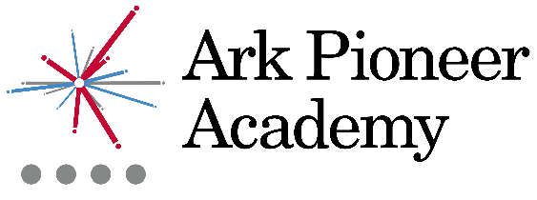

Job Description: Cook

Reports to: Chef Manager

The Role
As the Cook you will prepare, cook and present food which meets the school standards and according to the Chef Manager’s direction. You will also be responsible for working as an effective member of the catering team and ensuring high levels of food preparation and kitchen cleanliness is maintained across all kitchen and dining areas, as well as ensuring a high standard of catering service is provided.

Key responsibilities
Food
- Assist in the planning and preparation of innovative seasonal menus and cooking for special functions and events which encourage healthy and nutritional eating habits
- Ensure food is prepared in accordance with relevant regulations and the procedures expected by the Chef Manager

Kitchen Operations
- Deliver excellent standards of customer service
- Assist with stock control/stock taking including receiving and checking supplies and safe storage
- Instruct Catering Assistants in food production methods
- Carry out additional tasks concerned with the operation of the kitchen, as and when required by the Chef Manager

Other
- Actively promotes the safety and welfare of our children and young people
- Ensures compliance with Arks data protection rules and procedures
- Work with Ark Central and other academies in the Ark network, to establish good practice throughout the network, offering support where required
- Carry out any other reasonable tasks as directed by the Chef Manager

Person Specification: Cook

Qualification Criteria
- Relevant catering qualification
- Health & Hygiene Certificate L3 (desirable)
- First Aid qualification (desirable)

Experience
- Experience catering in large quantities, ideally within a school
- Experience of cultural diversity with particular reference to food preparation and dietary preferences (desirable)
- Knowledge of healthy eating and nutrition and creating related menu’s
- Good communication skills with children and adults

Personal Characteristics
- Genuine passion and interest in food and in helping children learn to eat healthily
- A robust awareness of keeping children safe, noticing safeguarding and welfare concerns, and you understand how and when to take appropriate action
- Belief that every student should have access to an excellent education regardless of background
- Excellent interpersonal skills, able to motivate and manage others effectively
- Professional outlook, detailed orientated and able to multi task and meet deadlines
- A team player that can work collaboratively as well as using own initiative
- Calm and professional under pressure
- Understanding of the importance of confidentiality and discretion
- Flexible attitude towards work and demonstrates sound judgement

Leadership & Management
- Vision aligned with Ark Pioneer’s high aspirations and high expectations of self and others
- Able to work in close harmony with the Principal and senior team
- Management style that encourages participation, innovation and confidence
- Ability to lead, coach and motivate staff within a performance management framework, including professional development and effective management of underperformance
- Strong interpersonal, written and oral communication skills

Other

- Right to work in the UK
- Commitment to equality of opportunity and the safeguarding and welfare of all students
- Willingness to undertake training
- This post is subject to an enhanced DBS check

Ark is committed to safeguarding and promoting the welfare of children and young people in our academies. In order to meet this responsibility, we follow a rigorous selection process. This process is outlined here, but can be provided in more detail if requested. All successful candidates will be subject to an enhanced Disclosure and Barring Service check.

