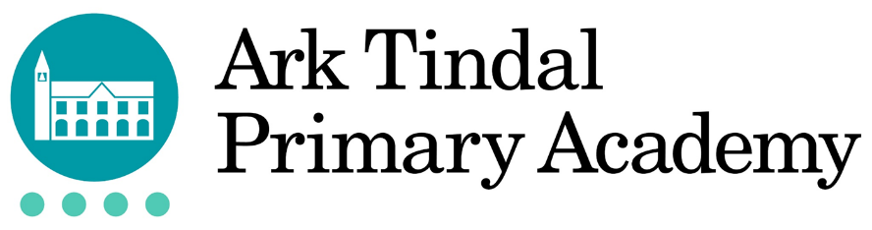

Ark Tindal Primary Academy, Tindal Street, Birmingham, B12 9QS
info@arktindalprimary.org 0121 464 3049 @arktindal

Job Description: Classroom Teacher
Reporting to: Senior Leadership Team
Location: Ark Tindal Primary Academy (Key Stage 2)
Contract: Fixed Term (initially)
Salary: Ark Mainscale point 1 - 3

The Role
The Classroom Teacher at Ark Tindal is responsible for delivering high-quality teaching and building positive relationships that enable all pupils to thrive. You will contribute to a culture of continuous improvement, coaching and shared responsibility for pupil success, supporting our mission to provide an exceptional education that enables every child to flourish into a confident, successful and well-rounded individual.

Key Responsibilities
- Uphold and model all aspects of the Teachers’ Standards
- Set consistently high expectations so that all pupils are inspired, motivated and challenged to achieve strong outcomes
- Plan and deliver well-structured, ambitious lessons aligned to the school’s curriculum, adapting teaching to meet the needs of all pupils
- Use assessment effectively to inform teaching, identify pupils who need additional support and ensure strong progress over time
- Establish and maintain clear routines and high expectations for behaviour, creating a calm, safe and purposeful learning environment
- Work collaboratively within the year group team, contributing to co-planning, lesson rehearsal and coaching as part of the school’s three-teacher model
- Act on feedback and engage fully in professional development to continually refine and improve teaching practice
- Enrich the curriculum through trips, visits and wider opportunities that build pupils’ cultural capital
- Build strong relationships with pupils, families and colleagues, contributing to a positive and inclusive school community
- Contribute to the wider life of the school, including attending key events and, where appropriate, leading extra-curricular activities

Other Responsibilities
- Safeguard and promote the welfare of all pupils, in line with statutory guidance and school policies
- Ensure compliance with Ark’s data protection policies and procedures
- Communicate effectively with colleagues and external stakeholders, demonstrating professionalism, discretion and good judgement
- Work collaboratively with Ark Central and colleagues across the network to share and develop effective practice
This job description is not exhaustive, and you may be required to undertake other reasonable duties as directed by your line manager.

Person Specification: Classroom Teacher
Qualification Criteria
- Qualified to teach and work in the UK
- Qualified to degree level or above
Knowledge, Skills and Experience
- Demonstrable commitment to raising attainment of all pupils, regardless of their background
- Excellent understanding of both subject and general teaching pedagogy
- Knowledge of the national primary education system, the primary curriculum, and the changing face of assessment
- Effective and systematic behaviour management
- Be or demonstrate the potential to become an exceptional teacher

Behaviours
- Act with honesty and integrity at all times
- Genuine passion for and a belief in the potential of every student
- A robust awareness of keeping children safe, noticing safeguarding and welfare concerns, and you understand how and when to take appropriate action
- Deep commitment to Ark’s mission of providing an excellent education to every student, regardless of background
- Exemplify a strong moral compass, showing dedication to the personal and character development of each pupil whilst investing in the school’s approach to the personal development of both pupils and staff
- Excellent interpersonal, planning and organisational skills
- Resilient, motivated and committed to achieving excellence
- Reflective and proactive in seeking feedback to constantly improve practice
- Commitment to regular and on-going professional development and training to establish outstanding classroom practice.
- Commitment to and understanding of professionalism in line with the National Teaching Standards

Other
- Right to work in the UK
- Commitment to equality of opportunity and the safeguarding and welfare of all students
- Willingness to undertake training
- This post is subject to an enhanced DBS check

Ark is committed to safeguarding and promoting the welfare of children and young people in its academies. In order to meet this responsibility, its academies follow a rigorous selection process to discourage and screen out unsuitable applicants.

Ark requires all employees to undertake an enhanced DBS check. You are required, before appointment, to disclose any unspent conviction, cautions, reprimands or warnings under the Rehabilitation of Offenders Act 1974 (Exceptions) Order 1975. Non-disclosure may lead to termination of employment. However, disclosure of a criminal background will not necessarily debar you from employment - this will depend upon the nature of the offence(s) and when they occurred. To read more about Ark’s safer recruitment process, please click this link.
We aim to build a diverse and inclusive organisation where everyone – staff and students – can do their best work and achieve their full potential. We want to reflect and represent diverse perspectives across our organisation because we know that doing so will make us stronger and more effective. To know more about Ark’s diversity and inclusion commitments, please click on this link.

