

Administrative Assistant / Receptionist

Reporting to: Operations Manager
Location: Ark Greenwich Free School
Contract: Fixed Term for one year or Permanent
Working Pattern: Part Time, Term-time only – Monday to Friday, 08:30
– 15:00
Start date: October / November 2026
Salary: Ark Support Staff Salary Scale, Inner London
Band 3, £29,801 - £31,083 pro-rata

Applications close: Wednesday 30th September 2026 at 11:59pm
Interviews: Week commencing 5th October 2026
The school reserves the right to withdraw this advert if a suitable candidate is appointed before the closing date. Applicants are strongly encouraged to apply early for this role to avoid disappointment.

Ark Greenwich

Click here to view our school video.
This is a rare and exciting opportunity to work at one of the highest performing schools in the country. If you are committed to making a lasting difference in our local community and want to work in a seriously ambitious, respectful and high performing school, this could be the job for you.

At Ark Greenwich we take the wellbeing and workload of our staff seriously. We are committed to sustainable high performance and recognise our staff are our primary resource. To find out how we approach staff wellbeing, please click here

Ark Greenwich exists to empower young people, regardless of socio-economic background, to grow and be successful. This is an ambitious and forward-thinking school that encourages innovation and values its staff. We are proud of our highly respectful and disciplined community and of the outstanding academic outcomes achieved by our scholars. Expectations for all members of our community are unashamedly sky high. We work tirelessly to impact the lives of the young people we serve. Scholars at our school are passionate about Humanities and achieve exceptional outcomes. We also place a primacy on our industry leading extra-curricular and character education programmes.
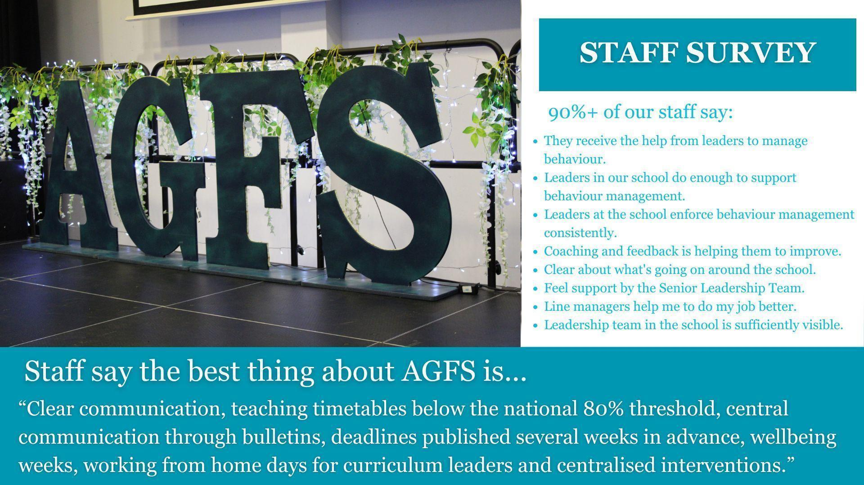

How is Ark Greenwich different?
- We are part of the Ark family of schools and benefit accordingly from outstanding networking and career opportunities and first-class CPD.
- Staff wellbeing is one of our main priorities. We provide breakfast for staff each morning, lunch for early careers staff and have a 6pm/weekend work-related communication cut off. We do not do knee jerk reactions, fads or last-minute deadlines. Our systems and processes for communication, marking and feedback and assessment are streamlined and the approaches we take are research led and based on our local context. We offer a WFH day to HoDs for curriculum design and also offer external marking of scripts to support workload. Our full approach to staff wellbeing/workload can be found here.
- This is a small school model (600 scholars aged 11-16) because we believe that our close-knit family community provides the optimum conditions for success.
- Scholar behaviour is exceptional with clearly defined and embedded routines. This means our teachers can focus their time on the things that matter – planning and delivering brilliant lessons for our scholars.
- This is a strict no excuses, no mobile phone school. Phones are not permitted onsite at all. Scholars wear business dress to prepare them for a professional career.
- Our curriculum is traditional and academic, and we do not take shortcuts to seek to boost our position in school league tables – we do not, for example, offer equivalencies such as Btecs or Vcerts..
- We put high-quality teaching at the heart of what we do. We are committed to providing staff with weekly high-quality training. We run coaching for staff who want to see rapid progress in their discipline. Live coaching and current best practice in the field of education is central to our approach.
- We don’t grade individual lessons or ask for lesson plans but we do place a primacy on curriculum design, independent learning and formative assessment.
- Our scholars enjoy a compulsory co-curricular program on a Wednesday afternoon which includes a strong focus on community volunteering and we facilitate 6 drop-down days per academic year ensuring scholars benefit from a range of life-enriching experiences.

Alignment with the school’s vision, values and approach to education is essential.
The Role and the Department
This is a Front of House and administration role, well suited to someone with a passion for customer service. You will provide a professional/positive first impression and support to all visitors, parents, scholars and staff. You will also provide important administrative and pastoral support. You will need to be unflappable, calm under pressure and enthusiastic in holding yourself and others to our high standards.
Applicants must be fully aligned with the school’s values and ethos as set out in this document and on our website: www.arkgreenwichfreeschool.org.
About Ark Schools
Ark is a network of high-achieving, non-selective schools and one of the country’s top-performing academy groups. We run 39 academies in London, Birmingham, Hastings and Portsmouth educating more than 26,000 scholars. 83% of Ark schools are now rated as good or outstanding by Ofsted.
Our aim is to create outstanding schools that give every scholar, regardless of their background, the opportunity to go to university or pursue the career of their choice.
To find out more about Ark Greenwich, please visit our website via www.arkgreenwichfreeschool.org
Ark value diversity and are committed to safeguarding and promoting child welfare. The successful candidate will be subject to DBS and any other relevant employment checks.

Job Description: Administrative Assistant / Receptionist

Reporting to: Operations Manager
Location: Ark Greenwich Free School
Contract: Fixed Term for one year or Permanent
Working Pattern: Part Time, Term-time only – Monday to Friday, 08:30
– 15:00
Start date: October / November 2026
Salary: Ark Support Staff Salary Scale, Inner London
Band 3, £29,801 - £31,083 pro-rata

Applications close: Wednesday 30th September 2026 at 11:59pm
Interviews: Week commencing 5th October 2026
The Role

This is a Front of House and administration role, well suited to someone with a passion for customer service. You will provide a professional/positive first impression and support to all visitors, parents, scholars and staff. You will also provide important administrative and pastoral support. You will need to be unflappable, calm under pressure and enthusiastic in holding yourself and others to our high standards.
Key Responsibilities

- Providing outstanding front-line customer service to scholars, parents, staff and visitors to the school as well as a high standard of administration duties.
- Assist the school’s receptionists with answering calls, dealing with visitors and presenting a positive image of the school that upholds the school’s values and ethos.
- Interacting with parents, carers, colleagues and visitors to the school, at all levels of seniority, with confidence, tact and professionalism.
- Ensure safeguarding procedures are followed for all visitors and appropriately handling incoming calls and enquiries.
- Ensure that all communications are correctly logged and routed to their intended recipients, or an appropriate member of staff, to ensure a quick and effective communication system.
- To provide general administrative support.
- To undertake reprographics work.
- To book cabs when required.
- To ensure that the reception area remains tidy and that literature and forms are updated and replenished as necessary.
- Willingness to be first aid trained in order to provide first aid to scholars and staff where necessary
- Responding to Oncalls
- Undertaking routine school duties, such as lunch duty.
- Assist with student welfare and liaise with parents where necessary
- Provide cover for other areas of the admin department and carry out all administrative duties when required and directed to do so by the Operations Manager.
Other

- To comply with policies and procedures relating to child protection, health and safety, confidentiality and data protection, reporting all concerns to an appropriate person.
- To play a full part in the life of the school community and encouraging students to adhere to school expectations.

This job description is not an exhaustive list and you will be expected to carry out any other reasonable tasks as directed by your line manager.

We reserve the right to bring forward the closing date at our discretion, early application is advised.

Person Specification: Administrative Assistant / Receptionist

Knowledge, Skills and Experience
- Previous experience of working as a receptionist/administrative assistant is desirable
- Professional telephone manner
- Excellent communication skills and customer service manner including dealing with a diverse range of people
- Excellent organisational and time-management skills
- High level of proficiency with Microsoft Office
- Working knowledge of management information system Bromcom is desirable
- A willingness to undertake further training
- A willingness to work after normal working hours if required
Behaviours
- Awareness of the school’s values and ethos
- Genuine passion for and a belief in the potential of every scholar
- A robust awareness of keeping children safe, noticing safeguarding and welfare concerns, and understanding how and when to take appropriate action
- Belief that every student should have access to an excellent education regardless of background.
- Professional outlook, detailed orientated and able to multitask and meet deadlines
- A team player that can work collaboratively as well as using own initiative
- Calm and professional under pressure
- Understanding of the importance of confidentiality and discretion
- Flexible attitude towards work and demonstrates sound judgement
Other
- Right to work in the UK
- Commitment to equality of opportunity and the safeguarding and welfare of all students
- This post is subject to an enhanced DBS check

